PROJECT MANAGEMENT:

ALPHA++

ONLINE DOWNLOADER



Submitted To: Dr. Swati Sharma

Submitted By: Hamza Khan (12103540)

Vrishti Gahlaut(12103528)

Dhruv Singh(12103533)

Sumit Bansal(12103530)

|  |  |  |  |
| --- | --- | --- | --- |
| |  |  | | --- | --- | |  | This Downloader is a free web application that allows you to download files,videos,sound clips from sites like YouTube, Facebook, Dailymotion and many more. All you need is the URL of the page that has the video you want to download. Enter it in the textbox above and simply click '**Download**'. Alpha ++will then fetch download links in all possible formats that the particular site provides and download it in the highest quality available.  **The main objective was to provide a downloader which can be faster than the already existing downloaders in the market so that it saves time and money .It also downloads the highest quality of the file which adds to its functionality!** | | **Project Outline &Objective** |

LIFE CYCLE:

*Selecting and initiating*— a project is proposed, planned BY THE TEAMMATES, and THE HEAD TEACHER APPROVES.

*Planning*—starts after the initial commitment, INCLUDES detailed planning BY MEMBERS AS WELL AS THE TEACHERS and ends when all TEAM MEMBERS accept the entire detailed plan.

*Executing*—includes authorizing, executing, monitoring, and controlling work until the customer accepts the project deliverables.

*Closing and realizing*—all activities after customer acceptance to ensure project is completed, lessons are learned, resources are reassigned, contributions are recognized, and benefits are realized.

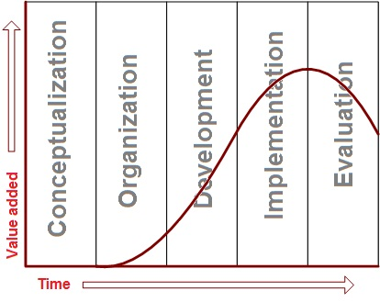

conventional life cycle:

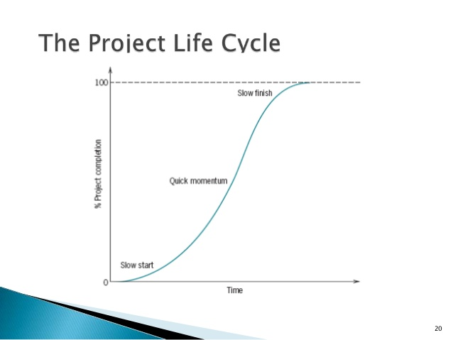

**This is what generally happens in the project –**

**It takes off with a slow start since people take time to adjust and implement,gradually they get used to it and that’s the time they perform best ,however by the time the deadline approaches they somewhat loose determination get exhausted reach saturation point.**

**HOWEVER**

**We took a precaution right from the start and divided the entire project in modules which led to a better result than the previous one ,continued inputs of effort at the end of the project produce significant gains in returns.**

**The graph went like this for completion v/s time only because of the extra efforts put in until the end.**

SWORT ANALYSIS:

|  |  |
| --- | --- |
| **Strengths:**   * **Downloads at a very high speed.** * **Saves time and money** * **Gives the highest quality results** * **Clients can chat.** | **Weaknesses:**   * **Team’s 1st product for launching in market. No experience in marketing and sales.** |

|  |  |
| --- | --- |
| **Opportunities:**   * This field will always have a lot of scope for growth ,since the main aim is at increasing the speed. * With development of technology, the weaknesses in the product will automatically be removed | **Threats:**   * **Faces a lot of competition .** * **The costs for a premium downloader might be an issue.** |

PEST ANALYSIS:

|  |  |
| --- | --- |
| **POLITICAL:**   * **Home market since there is a lot of competition.** * **Current/future legislation since the speed depends on bandwidth and maximum permissible bandwidth is determined by the laws.** * **Wars and conflicts since we can access a site of some other country only if we are at good terms with it.** * **Gives the highest quality results** * **Clients can chat.** | **ECONOMICAL:**   * **Home/international economies since it has a direct impact on the number of people paying for membership.** |

|  |  |
| --- | --- |
| **SOCIAL:**   * Consumer attitudes and opinions since ours is a newly launched product and lesser known brand. * Media views * Brand, company, technology image * Consumer buying patterns | **TECHNOLOGICAL:**   * **Faces a lot of competition.So Research funding is an important aspect.** * **Associated/dependent technologies.** * **Solutions for problems and betterment of the product.** |

Project Scheduling:

Estimated Time of the project:

* Time taken in project discussion: 2 days.
* Time in Resource Accumulation: 5 days.
* Time taken in software development: 30 days.
* Time taken in product and logo design : 2 days
* Time taken in marketing and launch: 10 days.

Project Planning:

**Project Team:**

This Project is to be executed with an efficient team of four, who are assigned specific tasks and goals to tackle in order to make the project a success. The team consists of following positions:

* Project Manager : To manage the smooth flow of the whole project and sub tasks.
* Chief Marketing Officer(CMO) : To ensure the marketing and publicity of the product.
* Chief Developers: Development of the software and designing.

(Regarding the responsibility matrix:

Here 1 denotes the highest say,2 lower than that and so on.)

RESPONSIBILITY MATRIX:

|  |  |  |  |
| --- | --- | --- | --- |
|  |  |  |  |
| |  |  |  |  | | --- | --- | --- | --- | |  | Project Manager | Chief Marketing Officer | Chief Developer | | Establish Project Plan | 1 | 2 | 3 | | Define WBS | 1 | 3 | 2 | | Establish Software Specification | 3 | 2 | 1 | | Establish marketing | 2 | 1 | 3 | |  |  |  |  |   Budgeting:  **Total Monetary Resource/ amount available:** 1500 INR  Resources and Components:   * Laptops: 0 INR * Softwares to help: 250 INR   Marketing:   * Advertisement: 500 INR * Product launch: 500 INR   Scheduling:  Crashing activities for Project cost optimization.  Activities and there short labels:   |  | | --- | | a-discussing and finalizing | | b-algo design | | c-software collection | | d-collecting financers | | e-algo implementing & simulation | | f-implementing logos | | g-testing | | h-debugging | | i-publicity | | j-merging of various modules | | k-advertisement | | l-prototyping | | m-finalizing | | n-product launch |  |  |  |  | | --- | --- | --- | | ACTIVITY | ACTIVITY / CRASHING TIME | PREDECESSOR | | a | 2/2 | - | | b | 5/3 | a | | c | 2/1 | a | | d | 10/5 | a | | e | 20/15 | c,b | | f | 2/2 | d | | g | 5/5 | e | | h | 5/5 | e | | i | 5/4 | f | | j | 3/2 | g,h | | k | 5/4 | i | | l | 3/2 | j | | m | 2/2 | l | | n | 5/5 | m,k |   Project Controlling:   1. **Performance Control:**   During the operation of the product, following performance issues might be expected to occur:   1. Device’s Battery might get low. 2. Overload of clients at the same time might result in slowing or hanging the system.      1. **Cost control:** 2. Marketing was done through flyers in newspapers as it was the most effective and economic way to reach the households and companies.   b) Depended on the costs that our competitors were charging.   1. **Time control:**   Most crucial part was to complete the project within reasonable time frame.   1. Since other companies or individuals have been working in the same direction since a long time a fast technology like this would be a break-through in the industry and if someone else would have launched the project, the credit would have gone in vain. 2. More the lag, more the probability that team loses focus and motivation. |  |  |  |
|  |  |  |  |
|  |  |  |  |
|  |  |  |  |